SQL MURDER MYSTERY SOLUTION

<https://mystery.knightlab.com/>

Context:  
A crime has taken place and the detective needs your help. The detective gave you the crime scene report, but you somehow lost it. You vaguely remember that the crime was a **​murder​** that occurred sometime on ​**Jan.15, 2018​** and that it took place in ​**SQL City​**. Start by retrieving the corresponding crime scene report from the police department’s database.

Step 1: Understanding the data structure:

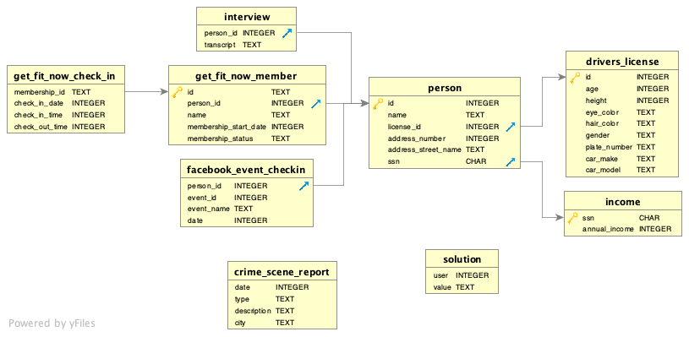

Step 2: gathering information

SELECT description FROM crime_scene_report

WHERE date = '20180115' AND type = 'murder' AND city = 'SQL City'

Output:

Security footage shows that there were 2 witnesses. The first witness lives at the last house on "Northwestern Dr". The second witness, named Annabel, lives somewhere on "Franklin Ave".

Step 3: Identifying the witnesses:

WITH witness1 AS (

SELECT id FROM person

WHERE address_street_name = 'Northwestern Dr'

ORDER BY address_number DESC LIMIT 1

), witness2 AS (

SELECT id FROM person

WHERE INSTR(name, 'Annabel') > 0 AND address_street_name = 'Franklin Ave'

), witnesses AS (

SELECT *, 1 AS witness FROM witness1

UNION

SELECT *, 2 AS witness FROM witness2

)

SELECT witness, transcript FROM witnesses

LEFT JOIN interview ON witnesses.id = interview.person_id

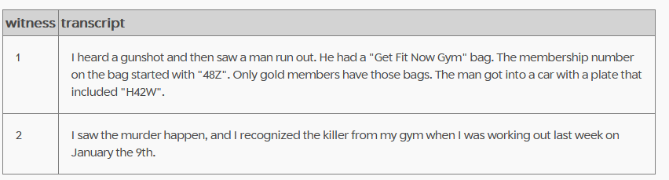

Step 3: Identifying the murderer:

WITH gym_checkins AS (

SELECT person_id, name

FROM get_fit_now_member

LEFT JOIN get_fit_now_check_in ON get_fit_now_member.id = get_fit_now_check_in.membership_id

WHERE membership_status = 'gold'

AND check_in_date = '20180109' -- Witness 2 recognized him on January the 9th

), suspects AS (

SELECT gym_checkins.person_id, gym_checkins.name, plate_number, gender

FROM gym_checkins

LEFT JOIN person ON gym_checkins.person_id = person.id

LEFT JOIN drivers_license ON person.license_id = drivers_license.id

)

SELECT * FROM suspects

WHERE INSTR(plate_number, 'H42W') > 0 AND gender = 'male'

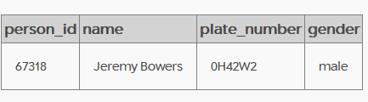

Step 4: Entering the solution

INSERT INTO solution VALUES (1, "Jeremy Bowers");

SELECT value FROM solution;

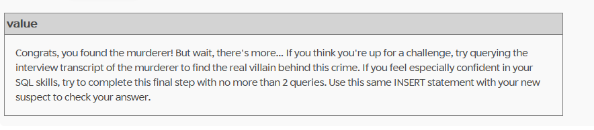

Step 5: Continuing the investigation

SELECT transcript FROM interview WHERE person_id = 67318

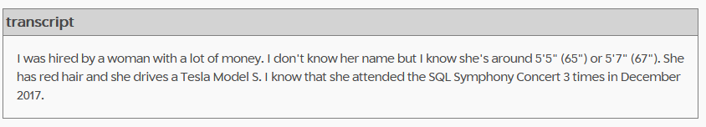

Step 6: Finding the true murderer

WITH red_haired_tesla_drivers AS (

SELECT id AS license_id

FROM drivers_license

WHERE gender = 'female' AND hair_color = 'red'

AND car_make = 'Tesla' AND car_model = 'Model S'

AND height >= 64 AND height <= 68

), rich_suspects AS (

SELECT person.id AS person_id, name, annual_income

FROM red_haired_tesla_drivers AS rhtd

LEFT JOIN person ON rhtd.license_id = person.license_id

LEFT JOIN income ON person.ssn = income.ssn

), symphony_attenders AS (

SELECT person_id, COUNT(1) AS n_checkins

FROM facebook_event_checkin

WHERE event_name = 'SQL Symphony Concert'

GROUP BY person_id

HAVING n_checkins = 3

)

SELECT name, annual_income

FROM rich_suspects

INNER JOIN symphony_attenders

ON rich_suspects.person_id = symphony_attenders.person_id

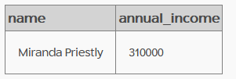

Step 7: Entering the solution

INSERT INTO solution VALUES (1, "Miranda Priestly");

SELECT value FROM solution;

